1. **Cài đặt PMM Server**

* 1. **Cài đặt Docker**

Tải docker tại địa chỉ: <http://mirror.centos.org/centos/7/extras/x86_64/Packages/docker-1.13.1-109.gitcccb291.el7.centos.x86_64.rpm>

Cài các gói phụ:

rpm -ivh atomic-registries-1.22.1-26.gitb507039.el7.centos.x86_64.rpm

rpm -ivh oci-umount-2.3.3-3.gite3c9055.el7.x86_64.rpm

rpm -ivh oci-systemd-hook-0.1.4-9.git671c428.el7.x86_64.rpm

rpm -ivh oci-register-machine-0-6.git2b44233.el7.x86_64.rpm

rpm -ivh container-storage-setup-0.11.0-2.git5eaf76c.el7.noarch.rpm

rpm -ivh container-selinux-2.107-3.el7.noarch.rpm

rpm -ivh atomic-registries-1.22.1-26.gitb507039.el7.centos.x86_64.rpm

rpm -ivh python-pytoml-0.1.14-1.git7dea353.el7.noarch.rpm

rpm -ivh atomic-registries-1.22.1-26.gitb507039.el7.centos.x86_64.rpm

rpm -ivh docker-common-1.13.1-109.gitcccb291.el7.centos.x86_64.rpm

rpm -ivh skopeo-containers-0.1.31-1.dev.gitae64ff7.el7.centos.x86_64.rpm

rpm -ivh docker-common-1.13.1-109.gitcccb291.el7.centos.x86_64.rpm

rpm -ivh libseccomp-2.3.1-3.el7.x86_64.rpm

rpm -ivh subscription-manager-rhsm-certificates-1.24.13-1.el7.centos.x86_64.rpm

rpm -ivh audit-libs-python-2.8.5-4.el7.x86_64.rpm

rpm -ivh checkpolicy-2.5-8.el7.x86_64.rpm

rpm -ivh libcgroup-0.41-21.el7.x86_64.rpm

rpm -ivh libsemanage-python-2.5-14.el7.x86_64.rpm

rpm -ivh libyaml-0.1.4-11.el7_0.x86_64.rpm

rpm -ivh python-IPy-0.75-6.el7.noarch.rpm

rpm -ivh python-backports-ssl_match_hostname-3.5.0.1-1.el7.noarch.rpm

rpm -ivh yajl-2.0.4-4.el7.x86_64.rpm

rpm -ivh python-ipaddress-1.0.16-2.el7.noarch.rpm

rpm -ivh python-backports-1.0-8.el7.x86_64.rpm

rpm -ivh setools-libs-3.3.8-4.el7.x86_64.rpm

rpm -ivh policycoreutils-2.5-33.el7.x86_64.rpm

rpm -ivh containers-common-0.1.37-3.el7.centos.x86_64.rpm

rpm -ivh python-setuptools-0.9.8-7.el7.noarch.rpm

rpm -ivh docker-client-1.13.1-109.gitcccb291.el7.centos.x86_64.rpm

rpm -ivh docker-1.13.1-109.gitcccb291.el7.centos.x86_64.rpm

rpm -ivh docker-1.13.1-109.gitcccb291.el7.centos.x86_64.rpm

[root@monitor-dev PMM_Docker]# rpm -ivh python-pytoml-0.1.14-1.git7dea353.el7.noarch.rpm

Preparing... ################################# [100%]

Updating / installing...

1:python-pytoml-0.1.14-1.git7dea353################################# [100%]

[root@monitor-dev PMM_Docker]# rpm -ivh atomic-registries-1.22.1-26.gitb507039.el7.centos.x86_64.rpm

Preparing... ################################# [100%]

Updating / installing...

1:atomic-registries-1:1.22.1-26.git################################# [100%]

[root@monitor-dev PMM_Docker]# rpm -ivh audit-libs-python-2.8.5-4.el7.x86_64.rpm

Preparing... ################################# [100%]

package audit-libs-python-2.8.5-4.el7.x86_64 is already installed

[root@monitor-dev PMM_Docker]# rpm -ivh checkpolicy-2.5-8.el7.x86_64.rpm

Preparing... ################################# [100%]

package checkpolicy-2.5-8.el7.x86_64 is already installed

[root@monitor-dev PMM_Docker]# rpm -ivh containers-common-0.1.37-1.el7.centos.x86_64.rpm

Preparing... ################################# [100%]

Updating / installing...

1:containers-common-1:0.1.37-1.el7.################################# [100%]

[root@monitor-dev PMM_Docker]#

[root@monitor-dev PMM_Docker]# rpm -ivh containers-common-0.1.37-3.el7.centos.x86_64.rpm

Preparing... ################################# [100%]

Updating / installing...

1:containers-common-1:0.1.37-3.el7.################################# [100%]

[root@monitor-dev PMM_Docker]# rpm -ivh container-selinux-2.107-3.el7.noarch.rpm

Preparing... ################################# [100%]

Updating / installing...

1:container-selinux-2:2.107-3.el7 ################################# [100%]

setsebool: SELinux is disabled.

You have new mail in /var/spool/mail/root

[root@monitor-dev PMM_Docker]# rpm -ivh container-selinux-2.77-1.el7.src.rpm

Updating / installing...

1:container-selinux-2:2.77-1.el7 ################################# [100%]

warning: user mockbuild does not exist - using root

warning: group mockbuild does not exist - using root

warning: user mockbuild does not exist - using root

warning: group mockbuild does not exist - using root

[root@monitor-dev PMM_Docker]# rpm -ivh container-storage-setup-0.11.0-2.git5eaf76c.el7.noarch.rpm

Preparing... ################################# [100%]

Updating / installing...

1:container-storage-setup-0.11.0-2.################################# [100%]

[root@monitor-dev PMM_Docker]# rpm -ivh oci-register-machine-0-6.git2b44233.el7.x86_64.rpm

Preparing... ################################# [100%]

Updating / installing...

1:oci-register-machine-1:0-6.git2b4################################# [100%]

[root@monitor-dev PMM_Docker]# rpm -ivh oci-systemd-hook-0.1.4-9.git671c428.el7.x86_64.rpm

warning: oci-systemd-hook-0.1.4-9.git671c428.el7.x86_64.rpm: Header V4 DSA/SHA1 Signature, key ID 192a7d7d: NOKEY

Preparing... ################################# [100%]

Updating / installing...

1:oci-systemd-hook-1:0.1.4-9.git671################################# [100%]

[root@monitor-dev PMM_Docker]# rpm -ivh oci-umount-2.3.3-3.gite3c9055.el7.x86_64.rpm

Preparing... ################################# [100%]

Updating / installing...

1:oci-umount-2:2.3.3-3.gite3c9055.e################################# [100%]

[root@monitor-dev PMM_Docker]# rpm -ivh docker-common-1.13.1-109.gitcccb291.el7.centos.x86_64.rpm

Preparing... ################################# [100%]

Updating / installing...

1:docker-common-2:1.13.1-109.gitccc################################# [100%]

[root@monitor-dev PMM_Docker]# rpm -ivh docker-client-1.13.1-109.gitcccb291.el7.centos.x86_64.rpm

Preparing... ################################# [100%]

Updating / installing...

1:docker-client-2:1.13.1-109.gitccc################################# [100%]

[root@monitor-dev PMM_Docker]# rpm -ivh subscription-manager-rhsm-certificates-1.24.13-1.el7.centos.x86_64.rpm

Preparing... ################################# [100%]

Updating / installing...

1:subscription-manager-rhsm-certifi################################# [100%]

[root@monitor-dev PMM_Docker]# rpm -ivh docker-1.13.1-109.gitcccb291.el7.centos.x86_64.rpm

Preparing... ################################# [100%]

Updating / installing...

1:docker-2:1.13.1-109.gitcccb291.el################################# [100%]

[root@monitor-dev PMM_Docker]# rpm -ivh libcgroup-0.41-21.el7.x86_64.rpm

Preparing... ################################# [100%]

package libcgroup-0.41-21.el7.x86_64 is already installed

[root@monitor-dev PMM_Docker]# rpm -ivh libseccomp-2.3.1-3.el7.x86_64.rpm

Preparing... ################################# [100%]

package libseccomp-2.3.1-3.el7.x86_64 is already installed

[root@monitor-dev PMM_Docker]# rpm -ivh libsemanage-python-2.5-14.el7.x86_64.rpm

Preparing... ################################# [100%]

package libsemanage-python-2.5-14.el7.x86_64 is already installed

[root@monitor-dev PMM_Docker]# rpm -ivh libyaml-0.1.4-11.el7_0.x86_64.rpm

Preparing... ################################# [100%]

package libyaml-0.1.4-11.el7_0.x86_64 is already installed

[root@monitor-dev PMM_Docker]# rpm -ivh policycoreutils-2.5-33.el7.x86_64.rpm

Preparing... ################################# [100%]

package policycoreutils-2.5-33.el7.x86_64 is already installed

You have new mail in /var/spool/mail/root

[root@monitor-dev PMM_Docker]# rpm -ivh python-backports-1.0-8.el7.x86_64.rpm

Preparing... ################################# [100%]

package python-backports-1.0-8.el7.x86_64 is already installed

[root@monitor-dev PMM_Docker]# rpm -ivh python-backports-ssl_match_hostname-3.5.0.1-1.el7.noarch.rpm

Preparing... ################################# [100%]

package python-backports-ssl_match_hostname-3.5.0.1-1.el7.noarch is already installed

[root@monitor-dev PMM_Docker]# rpm -vih python-ipaddress-1.0.16-2.el7.noarch.rpm

Preparing... ################################# [100%]

package python-ipaddress-1.0.16-2.el7.noarch is already installed

[root@monitor-dev PMM_Docker]# rpm -ivh python-IPy-0.75-6.el7.noarch.rpm

Preparing... ################################# [100%]

package python-IPy-0.75-6.el7.noarch is already installed

[root@monitor-dev PMM_Docker]# rpm -ivh python-setuptools-0.9.8-7.el7.noarch.rpm

Preparing... ################################# [100%]

package python-setuptools-0.9.8-7.el7.noarch is already installed

[root@monitor-dev PMM_Docker]# rpm -vih setools-libs-3.3.8-4.el7.x86_64.rpm

Preparing... ################################# [100%]

package setools-libs-3.3.8-4.el7.x86_64 is already installed

[root@monitor-dev PMM_Docker]# rpm -ivh skopeo-containers-0.1.26-2.dev.git2e8377a.el7.x86_64.rpm

warning: skopeo-containers-0.1.26-2.dev.git2e8377a.el7.x86_64.rpm: Header V4 DSA/SHA1 Signature, key ID 192a7d7d: NOKEY

error: Failed dependencies:

skopeo-containers < 1:0.1.31-2 is obsoleted by (installed) containers-common-1:0.1.37-1.el7.centos.x86_64

skopeo-containers < 1:0.1.31-2 is obsoleted by (installed) containers-common-1:0.1.37-3.el7.centos.x86_64

[root@monitor-dev PMM_Docker]# rpm -ivh skopeo-containers-0.1.31-1.dev.gitae64ff7.el7.centos.x86_64.rpm

error: Failed dependencies:

skopeo-containers < 1:0.1.31-2 is obsoleted by (installed) containers-common-1:0.1.37-1.el7.centos.x86_64

skopeo-containers < 1:0.1.31-2 is obsoleted by (installed) containers-common-1:0.1.37-3.el7.centos.x86_64

[root@monitor-dev PMM_Docker]# rpm -ivh yajl-2.0.4-4.el7.x86_64.rpm

Preparing... ################################# [100%]

package yajl-2.0.4-4.el7.x86_64 is already installed

[root@monitor-dev PMM_Docker]#

[root@monitor-dev PMM_Docker]# systemctl start docker

[root@monitor-dev PMM_Docker]# systemctl enable docker

Created symlink from /etc/systemd/system/multi-user.target.wants/docker.service to /usr/lib/systemd/system/docker.service.

[root@monitor-dev PMM_Docker]# systemctl status docker

â docker.service - Docker Application Container Engine

Loaded: loaded (/usr/lib/systemd/system/docker.service; enabled; vendor preset: disabled)

Active: active (running) since Sun 2020-04-12 18:33:24 +07; 21s ago

Docs: http://docs.docker.com

Main PID: 15041 (dockerd-current)

CGroup: /system.slice/docker.service

ââ15041 /usr/bin/dockerd-current --add-runtime docker-runc=/usr/libexec/docker/docker-runc-current --default-runtime=docker-runc --exec-opt native.cgroupd...

ââ15059 /usr/bin/docker-containerd-current -l unix:///var/run/docker/libcontainerd/docker-containerd.sock --metrics-interval=0 --start-timeout 2m --state-...

Apr 12 18:33:23 monitor-dev dockerd-current[15041]: time="2020-04-12T18:33:23.651863284+07:00" level=warning msg="Docker could not enable SELinux on the host system"

Apr 12 18:33:23 monitor-dev dockerd-current[15041]: time="2020-04-12T18:33:23.765010847+07:00" level=info msg="Graph migration to content-addressability too... seconds"

Apr 12 18:33:23 monitor-dev dockerd-current[15041]: time="2020-04-12T18:33:23.766668205+07:00" level=info msg="Loading containers: start."

Apr 12 18:33:23 monitor-dev dockerd-current[15041]: time="2020-04-12T18:33:23.812708755+07:00" level=info msg="Firewalld running: true"

Apr 12 18:33:24 monitor-dev dockerd-current[15041]: time="2020-04-12T18:33:24.215974685+07:00" level=info msg="Default bridge (docker0) is assigned with an ... address"

Apr 12 18:33:24 monitor-dev dockerd-current[15041]: time="2020-04-12T18:33:24.582438320+07:00" level=info msg="Loading containers: done."

Apr 12 18:33:24 monitor-dev dockerd-current[15041]: time="2020-04-12T18:33:24.641441169+07:00" level=info msg="Daemon has completed initialization"

Apr 12 18:33:24 monitor-dev dockerd-current[15041]: time="2020-04-12T18:33:24.641527749+07:00" level=info msg="Docker daemon" commit="cccb291/1.13.1" graphd...on=1.13.1

Apr 12 18:33:24 monitor-dev dockerd-current[15041]: time="2020-04-12T18:33:24.660009210+07:00" level=info msg="API listen on /var/run/docker.sock"

Apr 12 18:33:24 monitor-dev systemd[1]: Started Docker Application Container Engine.

Hint: Some lines were ellipsized, use -l to show in full.

[root@monitor-dev PMM_Docker]#

* 1. **Tải image PMM-Server 1.7**

Địa chỉ: <https://www.percona.com/downloads/pmm/>

* 1. **Tạo Docker Container từ PMM-Server image**

Load image vào docker:

docker load -i /opt/pmm-server-1.17.3.docker

[root@monitor-dev PMM_Docker]# docker load -i pmm-server-1.17.3.docker

77b174a6a187: Loading layer [==================================================>] 211.2 MB/211.2 MB

52c55236f8ff: Loading layer [==================================================>] 971.2 MB/971.2 MB

Loaded image: percona/pmm-server:1.17.3

[root@monitor-dev PMM_Docker]#

Tạo PMM-Server từ image:

docker create \

-v /opt/prometheus/data \

-v /opt/consul-data \

-v /var/lib/mysql \

-v /var/lib/grafana \

--name pmm-data \

percona/pmm-server:1.17.3 /bin/true

[root@monitor-dev PMM_Docker]# docker create -v /opt/prometheus/data -v /opt/consul-data -v /var/lib/mysql -v /var/lib/grafana --name pmm-data percona/pmm-server:1.17.3 /bin/true

6a287180500c161b1c7d9e0937470d3f8d3353cefc4f6a26e98b6246f15dec42

[root@monitor-dev PMM_Docker]#

docker run -d \

-p 9002:80 \

--volumes-from pmm-data \

--name pmm-server \

-e DISABLE_UPDATES=true \

--restart always \

percona/pmm-server:1.17.3

[root@monitor-dev PMM_Docker]# docker run -d -p 9002:80 --volumes-from pmm-data --name pmm-server -e DISABLE_UPDATES=true --restart always percona/pmm-server:1.17.3

abcad99cbca310471091364359de3a08313b2f49daf4887fc20522af958ff726

[root@monitor-dev PMM_Docker]#

Start PMM-Server:

docker start pmm-server

[root@monitor-dev PMM_Docker]# docker start pmm-server

pmm-server

[root@monitor-dev PMM_Docker]#

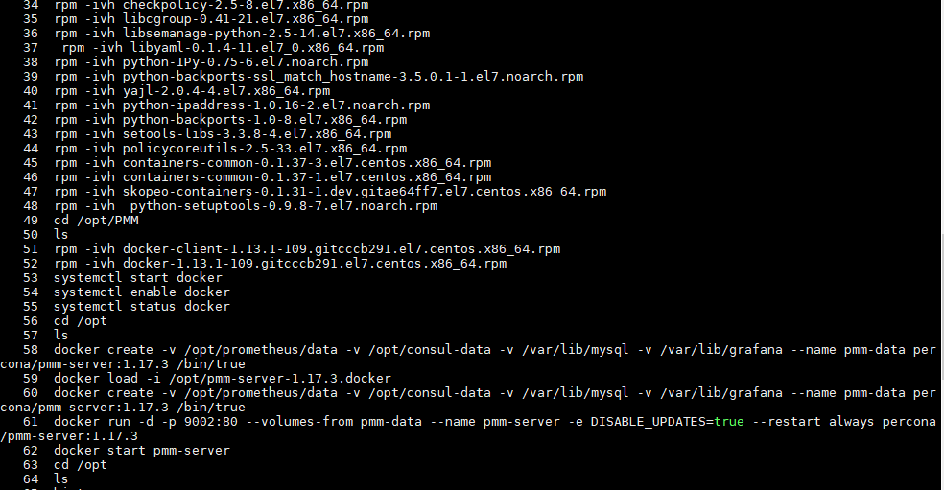

1. **Cài đặt PMM client agent**
   1. **Tải image PMM-Client 1.7**

Địa chỉ: <https://www.percona.com/downloads/pmm/>

rpm -ivh pmm-client-1.17.3-1.el6.x86_64.rpm

* 1. **Add monitor service**

**Add Node**

pmm-admin config --server 192.168.2.14:9002 --server-user admin--server-password admin

pmm-admin add linux:metrics

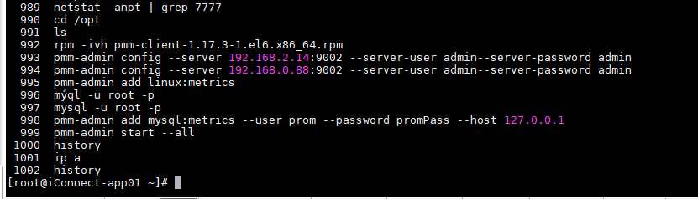

[root@Ung-tien-24h-DB3 opt]# pmm-admin config --server 192.168.1.32:9002 --server-user admin--server-password admin

OK, PMM server is alive.

PMM Server | 192.168.1.32:9002

Client Name | Ung-tien-24h-DB3

Client Address | 192.168.1.36

[root@Ung-tien-24h-DB3 opt]# pmm-admin add linux:metrics

OK, now monitoring this system.

[root@Ung-tien-24h-DB3 opt]#

**Add Mysql**

Đăng nhập vào MySQL bằng acc root và tạo tài khoản để gửi metric:

# Login vao MySQL voi quyen root va tao 1 tai khoan de monitor MySQL

GRANT REPLICATION CLIENT, PROCESS ON *.* TO 'prom'@'127.0.0.1' identified by 'promPass';

GRANT SELECT ON performance_schema.* TO 'prom'@'127.0.0.1';

FLUSH PRIVILEGES;

[root@Ung-tien-24h-DB3 opt]# mysql -u root -p

Enter password:

Welcome to the MySQL monitor. Commands end with ; or \g.

Your MySQL connection id is 4407

Server version: 5.7.26-29-57 Percona XtraDB Cluster (GPL), Release rel29, Revision 03540a3, WSREP version 31.37, wsrep_31.37

Copyright (c) 2009-2019 Percona LLC and/or its affiliates

Copyright (c) 2000, 2019, Oracle and/or its affiliates. All rights reserved.

Oracle is a registered trademark of Oracle Corporation and/or its

affiliates. Other names may be trademarks of their respective

owners.

Type 'help;' or '\h' for help. Type '\c' to clear the current input statement.

mysql> GRANT REPLICATION CLIENT, PROCESS ON *.* TO 'prom'@'127.0.0.1' identified by 'promPass';

Query OK, 0 rows affected, 1 warning (0.01 sec)

mysql> GRANT SELECT ON performance_schema.* TO 'prom'@'127.0.0.1';

Query OK, 0 rows affected (0.01 sec)

mysql> FLUSH PRIVILEGES;

Query OK, 0 rows affected (0.01 sec)

mysql> select user,host from mysql.user;

+------------------+-------------+

| user | host |

+------------------+-------------+

| monitor | % |

| vnpt_ba_report | % |

| prom | 127.0.0.1 |

| dev_ungtien | 192.168.1.% |

| vnpt_ba_core | 192.168.1.% |

| vnpt_ba_data_raw | 192.168.1.% |

| vnpt_gateway | 192.168.1.% |

| mysql.session | localhost |

| mysql.sys | localhost |

| root | localhost |

| sst | localhost |

+------------------+-------------+

11 rows in set (0.00 sec)

mysql>

pmm-admin add mysql:metrics --user prom --password promPass --host 127.0.0.1

[root@Ung-tien-24h-DB3 opt]# pmm-admin add mysql:metrics --user prom --password promPass --host 127.0.0.1

OK, now monitoring MySQL metrics using DSN prom:***@tcp(127.0.0.1:3306)

[root@Ung-tien-24h-DB3 opt]#

**Start tất cả các exporter:**

pmm-admin start –all

[root@Ung-tien-24h-DB3 opt]# pmm-admin start --all

OK, all services already started. Run 'pmm-admin list' to see monitoring services.

[root@Ung-tien-24h-DB3 opt]#